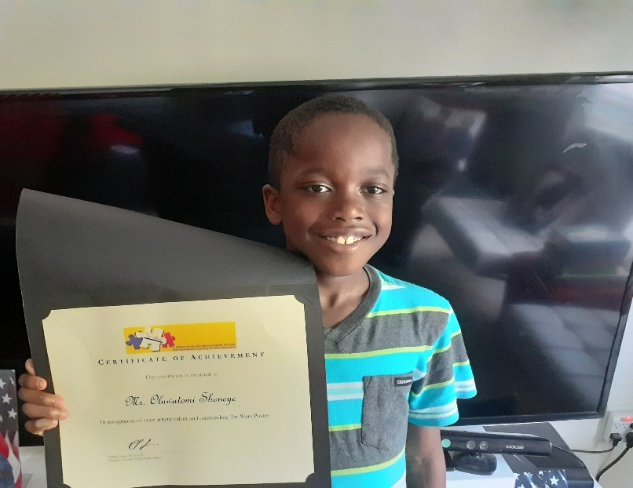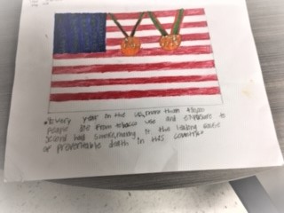

The Georgia Healthy Family Alliance 2019 statewide Tar Wars winners are **Oluwatomi Shoneye** from **Brumby Elementary School** in Marietta (pictured above) and **Kellie Sanford** **and Neyla Gonzalez** from **Statham Elementary School** in Barrow County. Poster winners received a Certificate of Recognition and a gift card provided by the WG Raoul Foundation Tar Wars Grant.

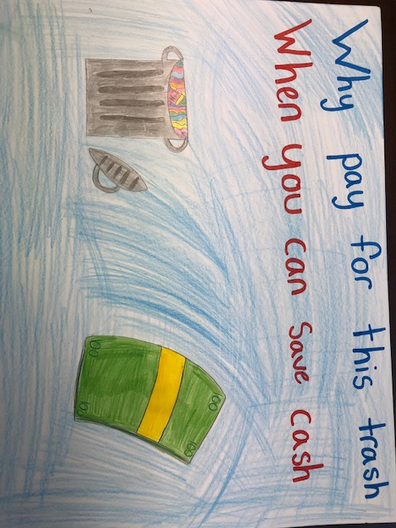

**Kellie Sanford** ~ **Statham Elementary School ~** **Barrow County**

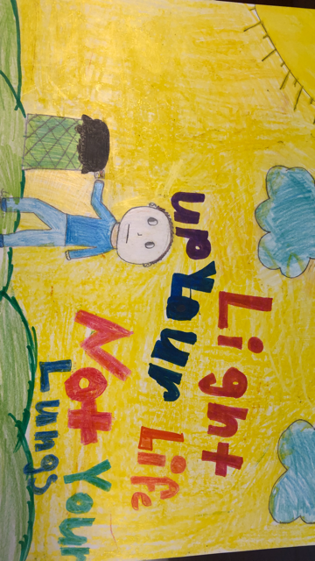

**Neyla Gonzalez** ~ **Statham Elementary School** ~**Barrow County**