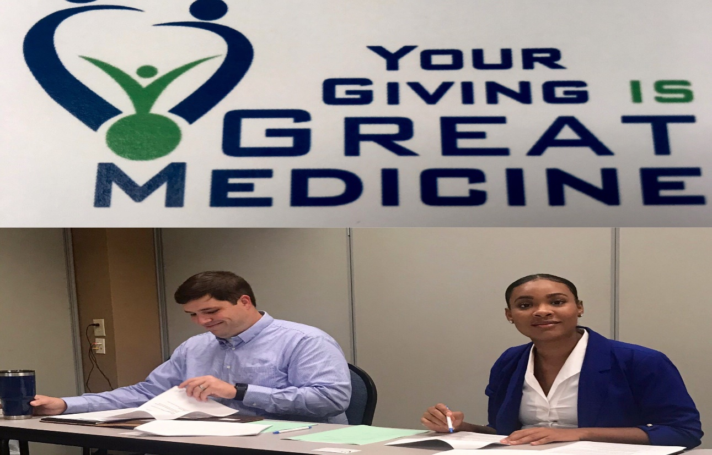
GHFA President Dr. Patrick “PJ” Lynn (L) and GHFA Director of Philanthropy Shan Hayes (R) prepare for the Rome Strike Force launch meeting.
GHFA Launches the Rome Strike Force!
The Georgia Healthy Family Alliance officially launched the 2019 Rome Strike Force tobacco and vaping education initiative August 8, 2019 in Rome. Alliance Board President Dr. Patrick “PJ” Lynn and co-chairs Dr. Leonard Reeves and Dr. Shelle Glover recruited a team of medical professionals and community leaders to help address the epidemic of youth vaping in Rome and surrounding counties.
The goal of the Rome Strike Force is to provide the Tar Wars tobacco/vaping education and prevention program to all 4th-12th graders in Floyd, Polk, Chattooga and Rome City schools. Recent national studies show that 1 in 5 high school students and 1 in 20 middle school students reported vaping in the past 30 days. The aim of this project is to demonstrate the dangers of these products before youth are ever offered their first JUUL or cigarette.
Tar Wars is a program that was developed in 1988 by Jeff Cain, MD and has touched the lives of more than 10 million children worldwide since its inception. The lesson plan consists of a one-hour presentation and requires minimum preparation from volunteers. The Georgia Healthy Family Alliance provides all lesson plans and materials needed, at no cost to the schools or volunteers. The Alliance also provides a stipend for the time and commitment of our volunteer presenters. For more information email Shan Hayes at shayes@gafp.org.

