The Road to A Healthier Georgia

Pivoting and Adapting During a Pandemic to Advance Our Mission
By: GHFA Board President Patrick “PJ” Lynn, MD, FAAFP

On behalf of the Georgia Healthy Family Alliance (GHFA) Board of Trustees, I am pleased to present the following report of the Alliance’s 2020 activities. This unprecedented year has allowed us to provide more care to our fellow Georgians than ever- and to be recognized nationally.

I must first thank the GHFA Board of Trustees for their service over the past year as we faced so much uncertainty as a result of the COVID-19 pandemic yet continued to move forward toward fulfillment of our mission to enhance the well-being of Georgians through educational and outreach programs.

Improving the Health of Georgians
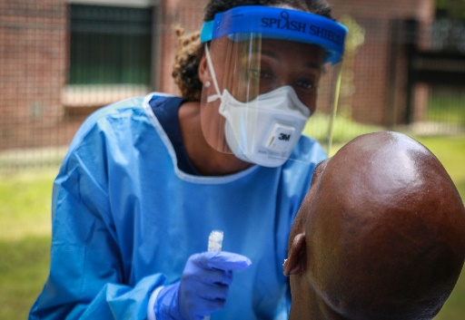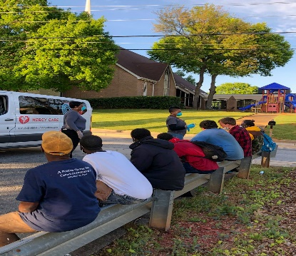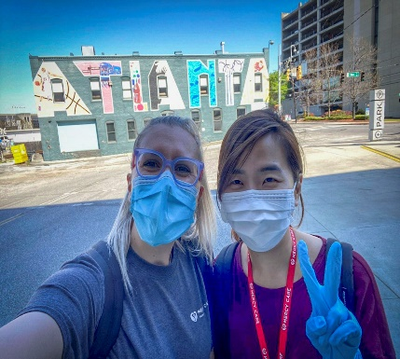

Immediate Needs Grants

The COVID-19 pandemic presented many challenges to the healthcare community and the patients they serve in Georgia. In response, the Alliance launched the Immediate Needs Grants program in March to help address some of the unique challenges Georgia’s communities faced due to the Coronavirus outbreak. With the knowledge that family physicians are on the front lines of public health issues affecting our communities, these grants were designed to provide up to $1,000 to support critical health needs for our most fragile citizens and patients. We have awarded $36,000 to projects including prescription assistance for homebound senior citizens, lunch delivery for vulnerable children who no longer had access to school meals, PPE for charitable care clinics, childcare services for first responders and sanitizer distribution for Atlanta’s large homeless community.
In late May, we received word from the AAFP Foundation that our Immediate Needs Grant Program was selected as the AAFP Foundation Outstanding Program of the Year! We are humbled to be recognized for our collective effort to help our patients and communities maintain health and hope during these uncertain times.
Immediate Needs Grants and their GAFP Sponsors (as of Oct. 1st):
Dr. Susan Land, Thomson, Lunch Delivery for Food Insecure Children and Seniors
Dr. Brandi Warren, Thomasville, Prescription Assistance/ Diabetic Supplies for Seniors
Dr. Cedrice Davis, Marietta, Food and Prescription Assistance for Patients in Need
Dr. Monica Newton, Gainesville, Diaper and Food Drive For Disabled Children
Dr. Sean Lynch, Augusta, Food, Transportation and Prescription Assistance for Patients
Dr. Navdeep Mangat, Atl, Sanitizer distribution and COVID-19 Testing For the Homeless
Dr. Leonard Reeves, Rome, Liquid Nutrition Delivered to Homebound Cancer Patients
Dr. Isabel Lowell, Decatur, Prescription Assistance for At Risk LGBTQ Youth
Dr. Raymond Bedgood, Dalton, Prescription Assistance For Low Income Patients
Dr. Daniel Grizzle, Athens, PPE Mask Production to Protect Patients and Staff

Dr. David Westfall, Gainesville, Prescription Assistance For Low Income Patients
Dr. Daniel Gordon, Colbert, Prescription Refills and Delivery for Chronically Ill Patients
Dr. Leslie David, Gainesville, Foodbank Distribution to Needy Families in Five Counties
Dr. Ken Howard, Calhoun, Food and Assistance for Homeless High School Students
Dr. Stalina Gowdie, Athens, Baby Care, Prescription Assistance & Food For Patients
Dr. Howard McMahan, Ocilla, Supplies & Support for First Responders in Rural Ga
Dr. David Davis, Athens, Food and Prescription Assistance for Unemployed Residents
Dr. Harry McDonald, Toccoa, Food for Homeless Families and Senior Citizens in North Ga.
Dr. Laura West, Tallulah Falls, Prescriptions for Patients Battling Drugs and Alcohol
Dr. Justin Rushing, Rome, Medications/Supplies for Insulin Dependent Diabetics & PPE
Dr. Mitch Cook, Athens, Grocery Gift Cards & Housing Assistance for Patients in Need
Dr. Jody Bahnmiller, Gainesville, Assist Rape Response Clients With Diapers, Food & Rent
Dr. Angeline Ti, Atlanta, Provide Blood Pressure Cuffs to Quarantined Pregnant Patients
Dr. Andrea Videlefsky, Marietta, Caring for Adults With Disabilities Via Telemedicine
Dr. Pedro Ramirez, Lawrenceville, Identifying and Triaging High Risk COVID-19 Patients
Dr. Beverly Townsend, Columbus, Provide Food and Transportation to HIV Patients
Dr. Suzanne Lester, Athens, Food Assistance For Homeless Families and Senior Citizens
Dr. Allison Turk, Dahlonega, Prescription Assistance and Food Delivery for Patients in Need
Dr. Charles White, Cleveland, PPE, Prescriptions and Diabetic Supplies for Patients in Need
Dr. Anthony Nazione, Rome, Food, Housing and Transportation for Cancer Patients
Dr. Alida Gertz, Decatur, COVID-19 Education, PPE and Hygiene Kits for the Homeless
Dr. Brian DeLoach, Statesboro, Prescription Assistance and Diabetic Supplies for Patients
Dr. Caroline Bekele, Atlanta, Assistance For Families Facing COVID-19 Income Loss
Dr. Robert Pyle, Rome, PPE For YMCA Staff Providing Childcare for First Responders
Grace Saxon, Atlanta, Student Run Women’s Health Services for Underserved Women
Dr. Beulette Hooks, Columbus, Food Assistance For Veterans in Need Due to COVID-19
Dr. Grace Baughn Kohler, Lawrenceville, Thermometers For Telemedicine Patients

Immediate Needs Grant applications are still available on our website at www.georgiahealthyfamilyalliance.org. Please reach out to Kara Sinkule at ksinkule@gafp.org or by calling (404) 321-7445 for more information.

The 2020 Community Health Grant Awards

In January 2020, the Georgia Healthy Family Alliance (GHFA) began its ninth year of the Community Health Grant Awards Program. Since its inception, the Community Health Grant Program has awarded nearly $400,000 in support of 80 GAFP member sponsored healthcare projects throughout Georgia. With the help of a matching gift from Jackson Healthcare, GHFA once again doubled the number of community health grants awarded in 2020. Traditional Community Health Grants awarded in 2020 included:

Grace Gate Clinic Flu Prevention For Habersham ,Donald Fordham, MD $5,000
Emory University Eagle Food Co-Op Project, Ava Voss, Student $5,000
Wellstar Kennestone FM Clinic Let’s Get Moving Project, Rebecca Kim, MD $5000
Al-Farooq Clinic Electronic Health Record Project Omar Hayek, Student $5000
Physicians Clinic Chronic Disease Management Program Martha Crenshaw, MD $5,000

Mercer School of Medicine Student Run Clinic Nicole Mette, Student $5,000
Clarkston Health Center, Breast Health Initiative Patrice Shongo, MD $5,000
Rome Free Clinic Telemedicine- Rural Communities Leonard Reeves, MD $5,000
DEO Clinic Telemedicine and Coaching Calls to overcome COVID Concerns While Monitoring Chronic Health Conditions Raymond Bedgood, MD $5,000

Adult Disability Get Fit&Be Healthy Project Andrea Videlefsky, MD $5,000
Warrior Centric Health Foundation & Veteran Medical Neighborhood Joining Forces to Mitigate Impact of Social Determinants of Health Loretta Hicks, MD $5,000
Mercy Health “Flu Prevention & Treatment Project Mitch Cook, MD $5,000

Philadelphia College of Medicine-GA “ Drive Through Flu Clinic Andrew Morrissey, Student $5,000

Current GAFP members including medical students, residents and active/ life members are eligible to sponsor applications for the next cycle grant funding with a deadline of February 1, 2021. First cycle grant awards will be announced in March 2021. Application information will be available online at www.georgiahealthyfamilyalliance.org in October.

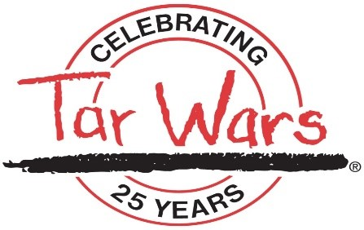

Tar Wars Kicks off 2020-21 School Year Virtually

Prior to the COVID-19 outbreak, Tar Wars was off to another record-breaking start to the year. Our part-time Tar Wars Coordinator, Deanna Kauten, RN, had already traveled to Athens, Henry, Dawson and Gwinnett counties to present Tar Wars to elementary and middle school youth before schools closed in response to the COVID-19 crisis. Medical students and residents at Augusta University presented the program to schools in their community and presentations were also held throughout Northeast Georgia. However, in mid-March across the board school closures resulted in the cancellation of dozens of previously scheduled Tar Wars classroom presentations.
In an effort to continue our progress spreading the Tar Wars tobacco and vape free message and to recruit additional presenters for the upcoming school year, Tar Wars staff conducted Tar Wars webinar trainings for school nurses and other interested parties online over the summer. The presentation detailed how vaping has been shown to increase the risk of serious complications with COVID-19 and how the Tar Wars program can be tailored for specific age groups. GHFA staff will continue to conduct webinars for school nurses and other interested parties on a monthly basis until schools reopen. Staff will also conduct online Tar Wars presentations for students wherever possible while schools continue virtual learning.
The Jackson Healthcare matching grant also included production of a powerful new video highlighting the importance of the Tar Wars program are by detailing one Georgia teen's journey to health after suffering a life threatening lung injury caused by vaping. The video is just three minutes long and can be viewed on the GHFA website www.georgiahealthyfamilyalliance.org.
If you are interested in presenting Tar Wars to a local elementary or middle school in your community contact Kara Sinkule at ksinkule@gafp.org for more information or visit www.georgiahealthyfamilyalliance.org.

Increasing the Financial Wellness of the Alliance

GHFA Capital Campaign- Your Giving is Great Medicine
The Alliance is now in the third year of the Your Giving is Great Medicine capital campaign and we are just $33,000 away from crossing the $2 million halfway mark! We need your help to make it happen. If 200 of our members donate $200 each we can reach that milestone before the end of the year! Will you help us get there?
The Capital Campaign has expanded our focus in specific Tar Wars Strike Force communities to raise $250,000 to implement our Tar Wars program for a minimum of three years in schools (or virtual schools) in an ongoing effort to curb the extraordinary increase in vaping among school aged children.
We launched in Rome and then followed in Gainesville last year and plan to wrap up our fundraising initiative in both of those areas in the coming months. In late September, we launched our Southeast Strike Force which will cover counties from Statesboro to Savannah.
As Alliance President and a resident of Rome, I chair the Rome Strike Force composed of family physicians, nurses, and community leaders. The Rome Strike Force is also being co-chaired by GAFP member, Dr. Leonard Reeves and we have received $100,000 pledges from Floyd Medical Center and the Floyd Medical Center Foundation to support our efforts.
GAFP member and Gainesville resident, Dr. Monica Newton, serves as Chair of the Gainesville Strike Force. Northeast Georgia Health System has signed on as a presenting sponsor with a $50,000 pledge. Dr. Fordham is serving as our Vice Chair of the Northeast Georgia Strike Force.
GHFA Board member and Statesboro resident Dr. Chip Cowart will serve as Chair of the Southeast Georgia Strike Force and Dr. Bonzo Reddick of Savannah will serve as Vice Chair. Southeast Georgia Strike Force members are currently being recruited.
Our goals for 2021 include raising another million dollars for our Capital Campaign. In addition, we expect to award $100,000 in community health grants and complete fundraising for the Gainesville, Rome and Savannah Strike Force initiatives which will allow us to launch Strike Forces in additional communities.

2020 Capital Campaign Leadership Cabinet Members

2020 Chair: Loy “Chip” Cowart, MD Dr. Mike Busman, Americus
Dr. Evelyn Lewis & Clark, Newnan
Dr. Donald Fordham, Demorest Dr. Patrick “P.J.” Lynn, Rome
Dr. Eddie Richardson, Eatonton
Dr. Mitzi Rubin, Atlanta
Dr. George Shannon, Columbus
Dr. Collyn Steele, McDonough
Dr. Harry Strothers, Macon
Dr. Rick Wherry, Dahlonega

As of October 1, 2020 the Your Giving is Great Medicine campaign pledges include:

$1,000,000
Georgia Academy of Family Physicians
$50,000- $100,000
Floyd Medical Center
Floyd Healthcare Foundation
Jackson Healthcare
Northeast Georgia Health System
$25,000-$49,999
Dr. Chip and Elizabeth Cowart
Dr. Patrick “PJ” and Lindsey Lynn
$15,000--$24,999
Phoebe Physicians Group

$10,000-$14,999
Dr. John Bucholtz
Dr. Mike and Dianne Busman
Dr. Samuel “Le” Church
Dr. Evelyn Lewis & Clark
Dr. Lanny and Mica Copeland
Dr. Donald Fordham
Fay Fulton
Dr. Gene and Ivy Jackson
Dr. Susan Margletta & Jack Harmon
Dr. Dayle Hawthorne
Dr. Thaddeus Lynn
Jim and Patti Lyons
Dr. Carl and Melanie McCurdy
Dr. Howard and Janet McMahan
Dr. Rolf Meinhold and Caryn Bains Dr. T.J. Miller
Dr. Adrienne Mims
Drs. Monica and Wylie Newton Dr. Mitzi and Jeremy Rubin
Dr. Eddie Richardson and Dr. Jameelah Gater
Dr. Michael and Deborah Satchell
Dr. George Shannon
Dr. Daniel Singleton
Dr. Collyn and Nick Steele
Dr. Harry and Karen Strothers
Dr. John Vu
Dr. David Westfall
Dr. Rick and Alice Wherry
$5,000-$9,999
Dr. Susana A. Alfonso
Dr. Karla Booker
Dr. Mitch Cook
Dr. Elvan Daniels
Dr. Daniel Grizzle
Dr. Thomas Fausett
Dr. Jay and Adelene Goberdhan
Dr. Emily J. Herndon
Dr. Audrey and William Hodge
Dr. Wayne Hoffman and Thomas Torrey
Dr. Beulette Hooks
Dr. Theresa Jacobs
Dr. Kevin and Connie Johnson
Dr. Bruce LeClair
Dr. Sherma Peter
Dr. James and Harriet Ray
Dr. Leonard Reeves and Terri Brown
Dr. Priya Shah Dr. Susan Schayes
Dr. Jeff and Holly Stone

$1000 -$4,999
Dr. Rami Arfoosh Dr. Thomas Bevill Dr. J. Larry Boss Dr. Michelle Cooke
Dr. David Fieseler
Dr. Loretta Hicks
Dr. Andre Kallab
Dr. Christina Kelly
Dr. Ambar Kulshreshtha
Dr. Anthony Nazione
Dr. Sharon Rabinovitz
Dr. Thad and Susan Riley
Shawn Smith
Dr. Charles Sow
Dr. Katherine Taylor
Dr. Beverly Townsend
Dr. Walter Steven Wilson

$500- $999
Dr. Rodneysha Brown (Resident)
Dr. Kristen Kettelhut (Resident)
Dr. Shameka Hunt McElhaney
Dr. Juilett Kostanjevec
Dr. Frank Lake
Dr. Shikha Shah

Rome Strike Force Donors
Floyd Medical Center
Emma Atherton-Staples MD
Floyd Healthcare Foundation
Kelly Vlass Culbertson MD
Patrick J. Lynn MD
Kirby Watson Peden MD
River City Bank
Jennifer Barbieri MD
Leonard Reeves MD
International Paper
Andrew Williams
Katherine Taylor MD

Gainesville Strike Force Donors
Northeast Georgia Medical Center

Rami Arfoosh
Jody Marie Bahnmiller-Brasil
Allen Butts Jr.
Carroll Daniel Construction
William L Coates Jr.
Committee to Elect Butch Miller
Committee to Elect Lee Hawkins
Leslie A David
Fay Fulton
Georgia Skin Center
Joy Griffin
Hasty Pope LLP
John L Hemmer Jr.
Jon Horn
Tate O’Rourke /Jackson EMC
Andre Kallab
Philip Olsen Kimsey
Frank G. Lake III
Douglas McDuff
Monica Suzanne Newton
Nhi-Kieu Nguyen
Kerri Prince
Stacey and Sara Reece
Marian Reed
Franklin Rinker
Karl Schultz
Margaret L Schutte
William H. Slack III
Wendell Starke
Starlet Rhodes Jones Fund at the North Georgia Community Foundation
James K Syfan III
Thomas C. and Alice Ann Mundy Fund
Daniel Thompson
James A Walters
David Noel Westfall
Richard Andre Wherry
Anslee Wilson

Savannah Strike Force Donors
Peter Bechtel
Scott Bohlke, MD
Sreevalli Dega, MD
Robert “Butch” Pallay, MD

2020 GHFA Board of Trustees

Patrick “PJ” Lynn, MD, President
Eddie Richardson Jr., MD, Vice President
Mitzi Rubin, MD, Treasurer
Michael Busman, MD
Evelyn Lewis & Clark, MD
Loy “Chip” Cowart, MD

Ambar Kulshreshtha, MD
Priya Shah, MD
Resident Trustees Rodneysha Brown, MD Juilett Kostanjevec, D

In closing, let me say how proud I am to be a member of the GAFP and President of the Alliance after seeing so many of my colleagues on the front lines of this pandemic going above and beyond to lift others in the face of this crisis through the Immediate Needs Grant program. Our collective efforts helped our patients and communities maintain health and hope during this difficult year. Thank you all again for your ongoing support of the Alliance.

